Ultrasonic welding generator

(JYD-2000H）
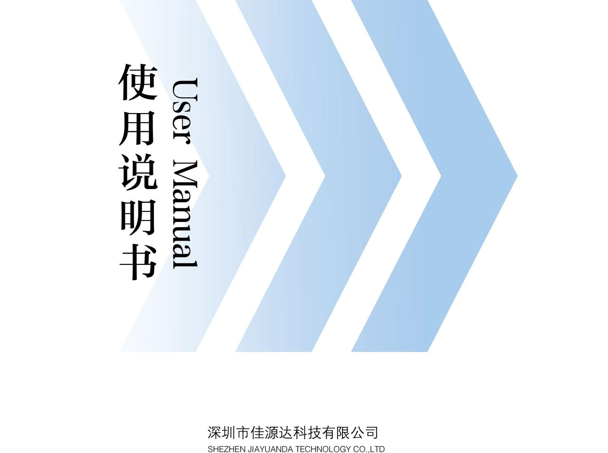

01. Overview

02. Main specification

03. Panel function and operation instruction

04. Generator tuning

05. Transducer and control port connection

06. Ultrasonic power adjustment

07. Horn installation

08. Scope of quality warranty
01. Overview

Welcome to use JYD company's welding ultrasonic generator. Our company's welding generator

use fly-back circuit,which track the transformation of transducer stably, stimulate the best proficiency of transducer, imported high power vacuum tube with good performance to resist the impact of big current, also enhance the stability of ultrasonic generator .

02. Main specification

Model No | JYD-2000H | JYD-2000H
Power | MAX2600W | MAX2000W
Power adjustment | Three power adjustable | Three power adjustable
Frequency | 15KHz | 20KHz
Voltage | 220V/110V±10% 50Hz/60Hz | 220V/110V±10% 50Hz/60Hz
Max current | 10A | 8A
Temperature | 0-40℃ | 0-40℃
Dimension | 400×580×145mm | 400×580×145mm

03. Panel function and operation instruction

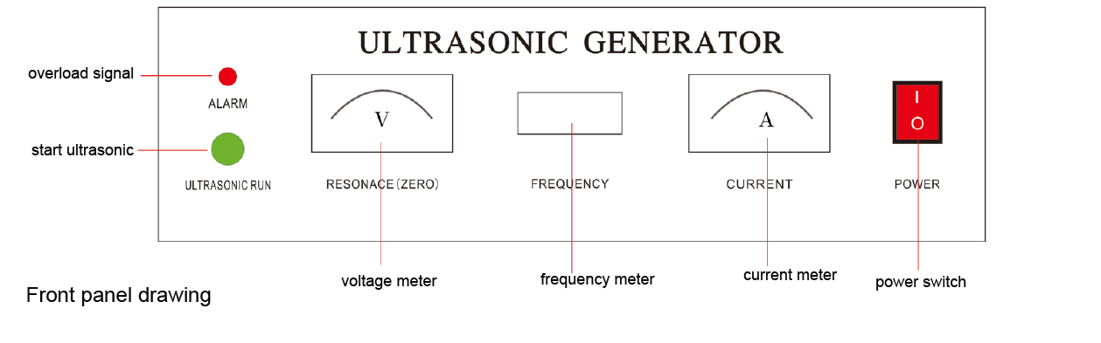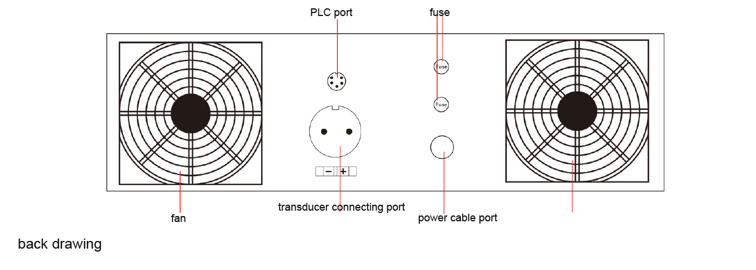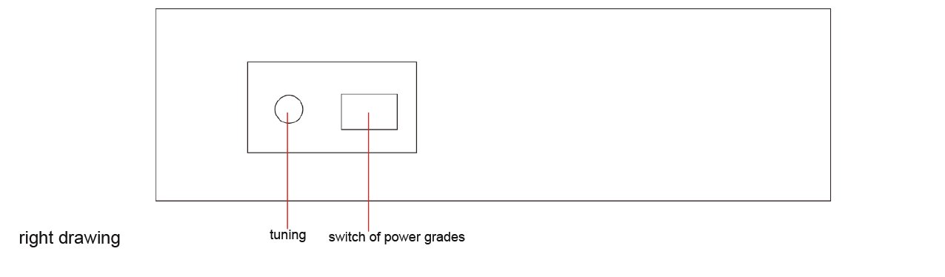

1.Preparation before tuning: plastic welding generator, before debugging, to confirm whether the frequency of the transducer and plastic welding generator is same. Such as, the frequency of the transducer is 20 Khz ±200 Hz, plastic welding generator frequency also should be 20 Khz±200 Hz. If the frequency is different, it is easy to damage the ultrasonic generator. (the company sale whole set machine, generator and transducer frequency are debugged before shipment, can't change the transducer casually.)If it is a separate generator, please customers reconfirm the amplitude frequency. And read the following content carefully.

2.Before connecting the power, make sure the power switch in the OFF state. In order to prevent electric shock, power cord must be ground connection.

3.During the connection of the Transducer, please pay attention to the vibration of the shell was negative (ground), the other side of the anode, the wiring of the red line, if meet the electric shock accidents can happen, so don't connect falsely. You can use a multimeter buzzer file, to determine the polarity of the transducer

4.The connection of circuit of transducer and generator, according to the positive and negative polarity of the transducer, then connect to the aviation port on the generator. As shown in figure 3.2.

04. Generator tuning

Before turn on the generator, go tuning at first.

At the first tuning, do not connect the external control port (figure 3.2), sonic run switch is in off state. When turn on the power of the generator, make sure the fan is working.

Before running the generator or installing the new transducer, booster or horn at the first time, must go tuning to let the whole ultrasound equipment work in the best state. The main performance show that ultrasonic vibration is uniform stability, current indicator is generally not more than 0.5 A, tuning indicates the minimum point in the middle.


No-load rough adjustment：

- remove the horn, open the small door on the right side of generator , change the power to 1 grade ，unscrew the nut，but the screw can't be moved.（3.3）

- turn on the switch , 1 second later. turn off the generator. at the same time. turn off the

switch of sonic run. to observe if the pointer of current raise quickly, after the pointer reach 1A, it will fall down slowly . at this moment , you can hear the soft voice of single frequency ultrasonic vibration. the voice decay accompanied by the pointer's fall down. the overload light turn off. Tuning voltage meter almost stay. the frequency display on the meter is the same with specification . above condition means this step has got success. we can g o ahead.
below is the failure phenomenon: the pointer raise and fall down too quickly . the voice of ultrasonic very short. the overload light turn on, the tuning voltage meter shake. To solve t his problem, you can fine tune screw of the frequency , rotate the screw 180. turn left or turn right. and repeat step 2

- observe the 4 basic demands, if the condition has some improvement , that mean you turn the screw in the right direction, just continue to turn the frequency screw in the same direct ion 180C. repeat step 2. until pass the step 2.

4. install the horn. firstly confirm the frequency is the same with generator and transducer. (Pls don't install the non-conforming horn with wrong frequency, it will damage the generat or ). after installed the horn, pls repeat step 2 to adjust, until reach the 4 basic demands.

No-load carefully adjustment：

- turn off the switch and click the button of sonic run. the pointer of current is in the 0.5A, soft voice of single ultrasonic vibration . overload light no display, the pointer of resonant voltage meter show small numerical. the pointer of frequency meter is in the resonant frequency. touch the shell of ultrasonic by hand, you will feel the vibration, very smoothly, like covered a soft film.

- continue to click the button of sonic run, fine tune the screw of frequency. observe the pointer of current , if the current less than 0.5A, it's ok. normal voice of ultrasonic vibration, overload light no display, data display on the voltage become less and less. almost to zero . the frequency meter has small vibration . above condition means this step has got success . we can go ahead

Load carefully adjustment：

1.immerse the horn to liquid as you need.

2. turn off the switch and click the bottom of sonic run. record the max current on the

current meter. it's the actual working current. there will be the voice of ultrasonic cavitation in the liquid , the voice can be loud. overload light has no display. the tuning voltage meter shows small numerical, the frequency meter shows resonant frequency.

3.continue to click the bottom of sonic run, find turn the screw of frequency , there will be the voice of ultrasonic cavitation in the liquid .overload light has no display, data display on the voltage become less and less. almost to zero . the process of adjusting ultrasonic machine is finished.

- Tighten the nut, avoid the tuning screw loose. Normally , you needn't repeat the tuning process when next time you use the machine

05. Transducer and control port connection

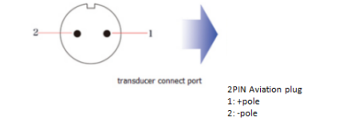
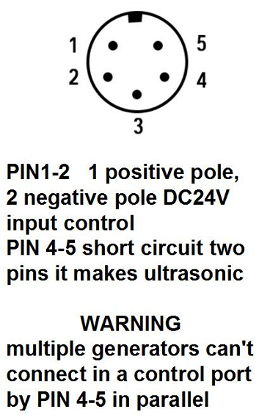

After the completion of the tuning, you can use remote switch to control the generator!

06. Ultrasonic power adjustment

In the condition of transducer, generator, booster and horn fixed, you can use Power control grade to control the power, but indicator current can't exceed the max current of this machine. the temperature of the horn and transducer can't exceed 80C
turn off the switch of generator, you can enhance the output by adjusting 1,2,3 grade. you need to make sure the pointer of tuning return to zero, if the overload light on, please do some tuning .

07. Horn installation

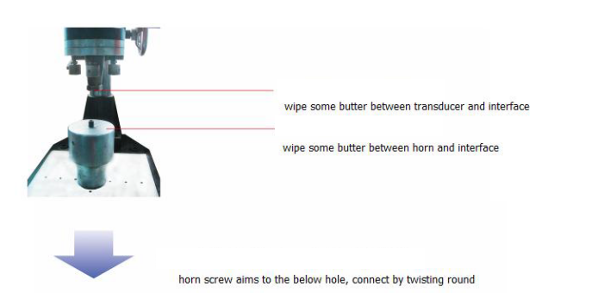
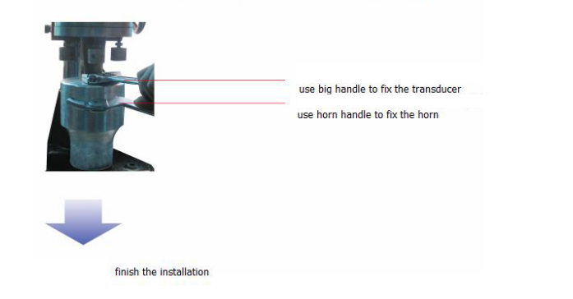

08. Scope of quality warranty

In normal use, generator and transducer has one year guaranty.
The connecting thread between horn and transducer is out of the warranty scope.

